**9 Myths about Starting in Data Science**

**Thinking about career change into data? Check common prejudices about getting job as a junior.**

One of my first data analysis project was fun.

Are you thinking about a new career in a promising data science field? If a former coal miner or opera singer can do it, you can probably do it too.

I have been there, not in the mines though, nor torturing an audience with my high pitched voice. I jumped from writing articles about electric cars and tech gadgets into writing lines of code in Python.

Disclaimer: Data science is used as a wide term including jobs like data scientist, data engineer, data analyst and even those quirky people who are still happy using MS Excel or MS Access.

My first course to get into data that I took, was a 3-months intensive course about data (SQL, Python and Power BI) from the organization [Czechitas](https://www.czechitas.cz/en), whose goal is to get more women into IT and the data industry. But it was not the last one. Learning never stops, even after getting hired.

What are a few common myths or misconceptions that can stop doubtful persons from pursuing their goal to get jobs in emerging data fields?

**1) You don’t have to be a math genius**

Of course, it does not hurt to be one. But your talent in numbers might be wasted on data science. Go on tour to the nearest casinos, play poker at a professional level, or just make a few betting companies lose their money.

Except for certain data jobs in research, you won’t need to understand more math then a lazy high-schooler. Of course, it’s better if you do, but even **the most complex machine learning models are highly automated nowadays**. For example, you won’t need to know the equation for Bayes theorem by heart, your computer will, so you can focus on other things.

**2) Certifications can be diamonds, but also trash**

Some certifications are hard to pass and proving your skills separates you from the rest. But more often, you can find certifications that you need to pay for registering and even after getting the certificate, **it is not something so special or necessary to have to enter the data field**.

For example, you probably won’t need t[o pay over 200 EUR to get certified in writing SQL queries](https://education.oracle.com/buy-exam). Most companies can easily test your knowledge in this area, if they find it useful for their future employees.

Also, if you do little searching, you can get (otherwise paid) exams for useful certifications completely for free. This is true for example for various exams for [MS Azure that anyone can take without paying](https://medium.com/geekculture/how-to-pass-certification-az-900-ms-azure-fundamentals-for-free-82fcf59c0b4d) single dollar or euro.

**3) Senior analysts and developers use Stack Overflow too**

Don’t be afraid to ask questions when you don’t understand something or your senior co-workers just used a term you had heard for the first time in your life. **Data is a fast-evolving field, so lots of things are changing quite quickly and you cannot always be up to speed** in all areas.

Moreover, rest assured that even your more experienced colleagues probably google answers for some of their tasks on the [Stack Overflow website](https://stackoverflow.com/) or similar sites at least once a week, if not daily.

**4) Coding and programming is not just for guys like Sheldon**

Sure, Sheldon Cooper is a theoretical physicist, so we are not sure if he actually knows any Java or PHP, but I guess you get the main message.

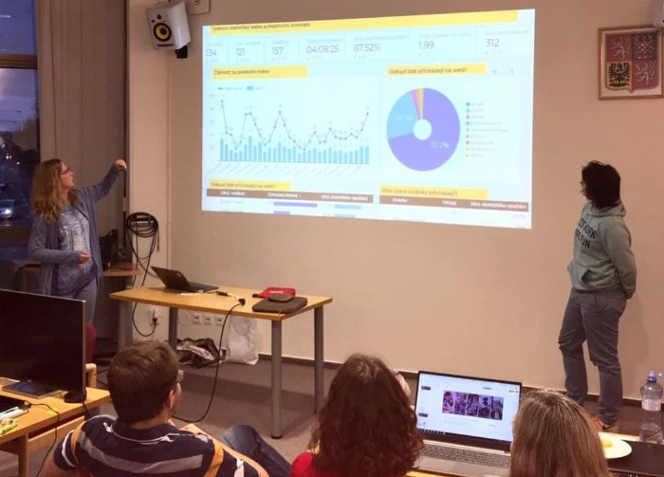

Did you know, that majority of data analysts hate pie charts to death? Photo: Czechitas, published with permission of Czechitas z.ú.

Also, I did not make up the story about the [coal miner who quit his job in mines to become SW developper](https://www.youtube.com/watch?v=mIja2lBKwdM) or the opera singer who switched into data analytics. These are all real events.

**5) The most important thing about a presentation is not its content**

You will be asked to do many presentations in your life if you are working in any kind of office job. Even though, the first question that people who are asked to present something for others usually ask is:

* What is the topic of my presentation?
* How long should the presentation be?

It’s not the most important question. Instead you should ask:

* Who will I be presenting to?
* Who will be in my audience? Young people? Experienced professionals? what nationalities, genders, etc.?

**The topic might be the same, but what you say should vary highly on the people who will listen to you**.



It is not about what you say, it is about how you say it. Photo: Czechitas (<https://www.czechitas.cz/en>), published with permission of Czechitas z.ú.

Even though you spend many days building and fine-tuning some complex machine learning algorithm, if you are giving a presentation to business users, most likely they won’t care about it. They would be only interested in the final result and what the impact of it is for their business and clients.

**6) You can’t catch them all; nobody is Ash Ketchum**

AWS, MS Azure, GCP and now even Snowflake and other companies are joining the **“cloud wars”** to determine which will be the one cloud vendor to rule them all in the end. **There are many rivalling technologies and tools in almost every domain of data science and data analytics**.

You can’t master them all and it also does not even make sense to try. There is only one master from Pallet Town who can catch them all and it’s because he was helped by his special yellow friend along the way.

**7) Machine learning and neural networks is cool, but…**

Most companies actually won’t need solutions using deep learning or unsupervised machine learning methods.

They probably won’t have enough data or enough clean data to make these algorithms work properly, or **they simply won’t need a complex solution using ML**, when something more straightforward is available, and cheaper. Using just simple statistical methods is often sufficient enough.

**8) You don’t need MS Excel, but…**

Spreadsheets in Excel have many limitations and there are many more practical tools that can do the same thing, but faster and also much more.

But sooner or later, **you will meet someone whose peak IT skills means sending and receiving Excel files** as attachments in email communication. And you will need to find common ground with this person, even though you know you could automate the same task with Python code.

Some people will just want to get their Excel report in the same way they have been getting it for last 10 years. You may try to change their opinion and show them other alternatives, but it might not always work.

**9) HR people usually don’t know what IT or data teams want**

And it is no wonder. Even IT and data professionals find it hard to keep up with always evolving field. So it would be impossible to expect it from HR specialists.

Sometimes you will need to point out to them that if a person is quite skilled in data visualizations in Power BI, using a tool like Tableau will probably be a piece of cake for them. Or that you actually don’t need X+ years of experience to be operative using certain tools, when they can be learned in matter of days or weeks. Well, for sure, you can try to convince them and they might not believe you, but that’s not your problem.

**Summary of common prejudices of juniors about data science field:**

* “Einstein level of math” knowledge in not needed.
* Not all data and IT certifications have real value on the market. Pick them wisely.
* Don’t be afraid to ask questions and google solutions.
* Programming is not an activity limited only to members of the Mensa club (a club that requires its members to be among 2 % of people with the highest IQ).
* When presenting something, it’s more important for whom than what.
* You can’t catch all the Pokémon nor master all technologies on the tech market.
* Machine learning skills are nice to have, but not a deal breaker.
* MS Excel is not outdated, yet.
* Some HR requirements in job descriptions might not be realistic. So don’ t hesitate to also apply for jobs where you don’t tick all the boxes.

Are you eager to switch your career into data science field and you may have some fears about going into the unknown? Then the one important takeaway from this article is:

Don’t believe others who are telling you it is not possible (to enter data science from totally different field) and also don’t trust that anxious voice inside your brain that is telling you the same thing.

If you are determined enough, it will work out. It might not happen right away after you will finish chosen data course or bootcamp, but if you persist, eventually you will get there. If the coal miner did it, you can too.